- The recent change to the UK's fiscal rules suggests policy will be looser in future, and we expect the new US policy landscape will mean higher, more volatile inflation across the world. As a result, we've raised our forecast for the long-run neutral UK interest rate by 50bps to 2.5%.
- Our forecast for Bank Rate over the long term is around 125bps lower than the level implied by current market pricing. We think the difference is partly because markets anticipate even higher inflation. But we also expect demographics and weak productivity growth to exert a substantial drag on the real neutral rate. The path back to neutral is likely to be gradual.
- In the near-term, we expect the UK term premium will remain elevated. Concerns about fiscal sustainability are unlikely to go away, while the government is yet to offer a convincing plan for boosting growth. Markets will also have to absorb a lot of extra gilt issuance at the medium- and long-end of the curve due to the increase in borrowing announced in the Budget.
Earlier this year we set out our approach for modelling the UK's long-run neutral interest rate – the rate where monetary policy is neither stimulatory nor restrictive. We found that the neutral rate had risen to just below 3% in 2023, after the pandemic and energy shock had lifted inflation expectations. But with inflation expectations set to fall back again, we argued the structural forces that have pushed rates down since 1980 would reassert themselves. As a result, we had expected the neutral rate would fall to 2% by 2030.
Two recent events – the change in UK fiscal rules and the anticipated shift in US policy under President-elect Donald Trump – now lead us to believe that the neutral rate will stay higher. We now expect Bank Rate will settle at 2.5%, 75bps below the median expectation for the neutral rate from November's Bank of England Market Participants Survey. Furthermore, our forecast for Bank Rate in 2030 is around 125bps lower than the level implied by current market pricing (Chart 1).
Chart 1: We raised our long-run forecast for Bank Rate, but it's still much lower than markets expect
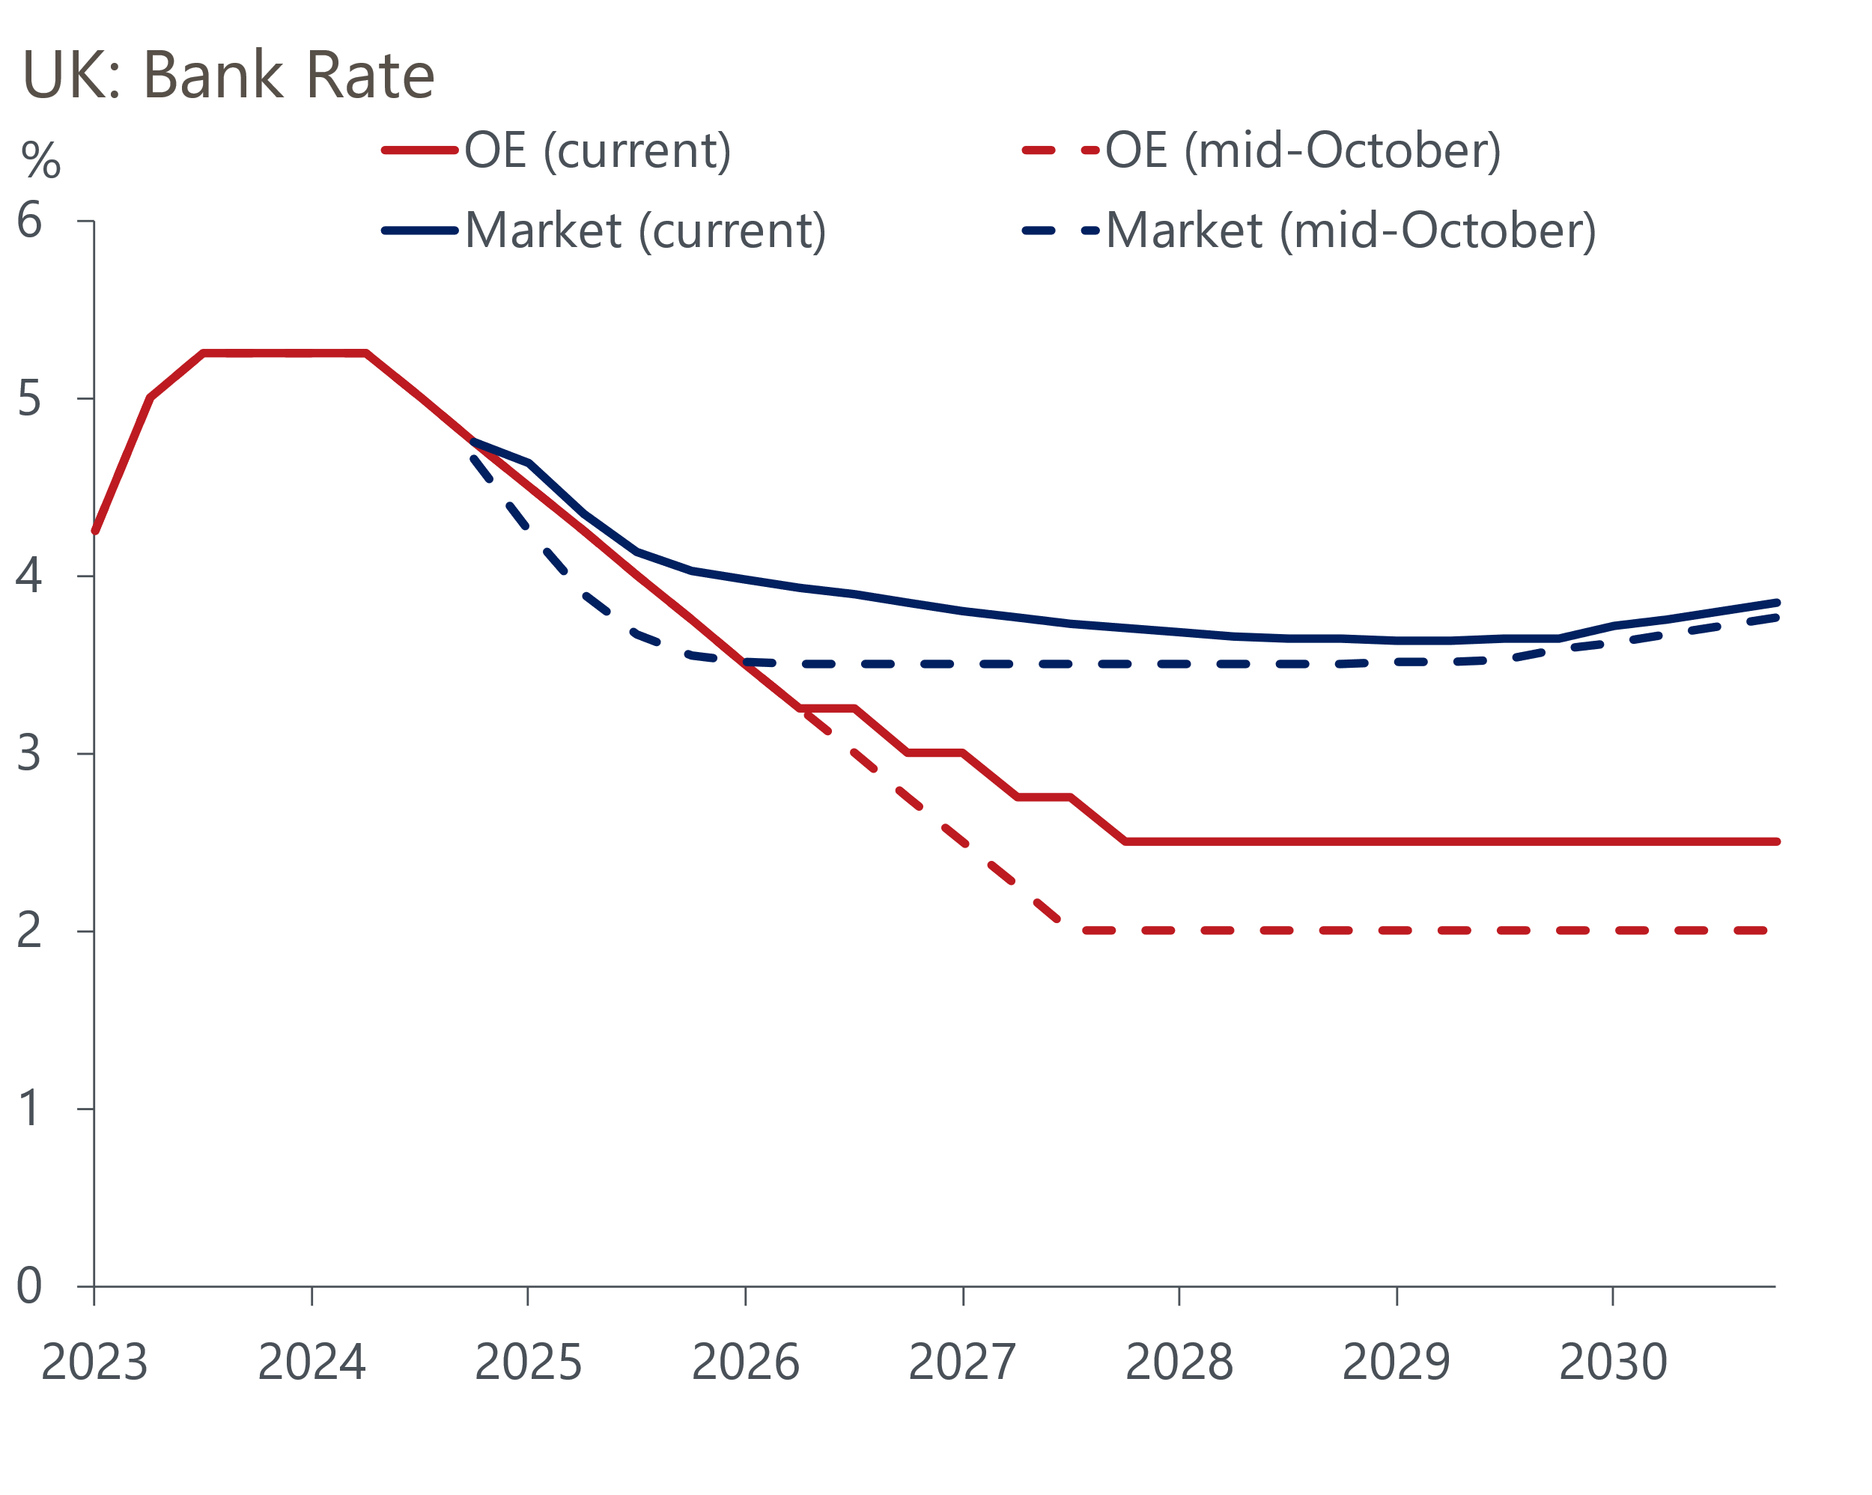
Sources: Oxford Economics, Haver Analytics

Looser fiscal rules and higher inflation expectations will increase the neutral rate
Our earlier research found that rising government debt had been the main structural force putting upward pressure on the neutral rate over the past 20 years. We had expected the public sector net debt-to-GDP ratio would drop back a little in future, reflecting the fact that the fiscal rules required the government to set policy so as to lower debt within a rolling five-year window, and that most of the increase in debt in the past two decades happened during or immediately after the two major shocks: the global financial crisis and the pandemic.
However, the new government has changed the measure used in the debt rule. The new administration will target a falling ratio of public sector net financial liabilities to GDP. This represents a looser constraint on policy, and the evidence of the Budget suggests that the Chancellor intends to use most of the additional headroom that the new rule permits. For example, our forecast for the ratio of public sector net debt to GDP is now 9ppts higher for 2040, with the gap getting ever wider (Chart 2). Adopting a permanently looser fiscal stance is consistent with a higher real neutral interest rate.
Chart 2: Permanently looser fiscal policy is consistent with a higher neutral interest rate
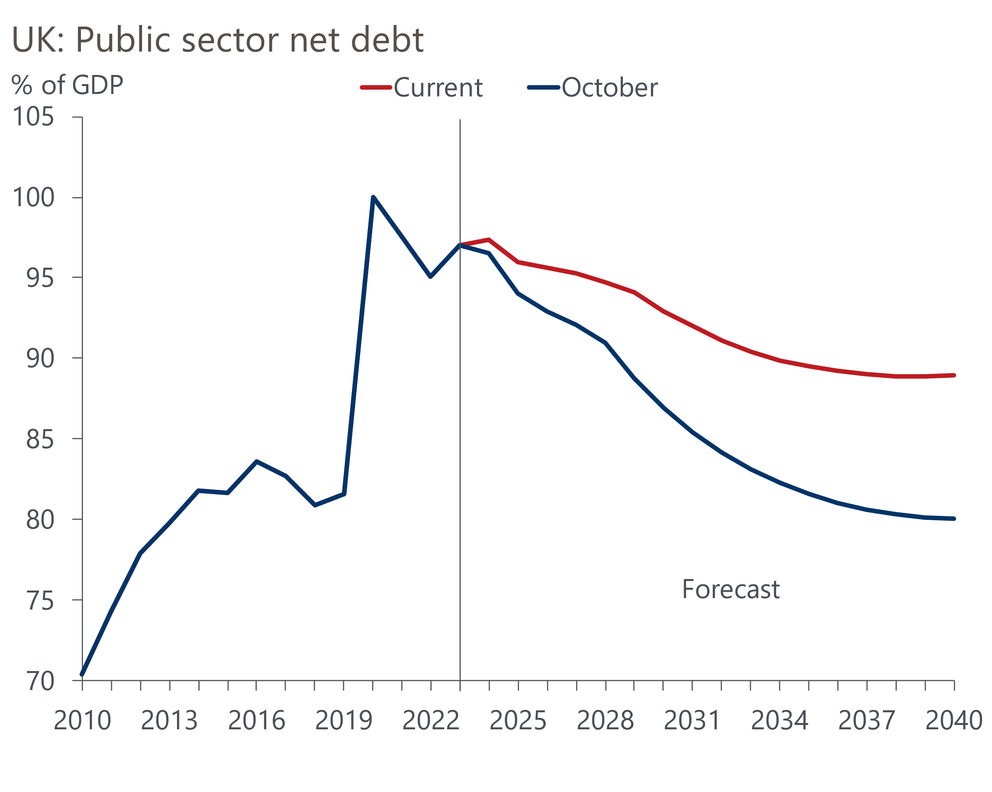
Sources: Oxford Economics, Haver Analytics
We also think that inflation expectations are likely to remain higher, reflecting the new policy landscape. The prospect of higher tariffs on imports into the US, and looser US fiscal policy, suggests that inflation is likely to be higher and more volatile globally.
Initially, changes to financial market pricing implied a similar view of the impact on the medium-term outlook for interest rates as ours. But markets subsequently repriced, and current pricing implies that Bank Rate will be around 3.75% at the end of the decade, similar to the level anticipated in mid-October. This is still well above our own forecast (Chart 1).
Given market pricing effectively shows the average of the assumptions made by a wide range of different organisations, it's hard to be specific about why markets expect the policy rate to settle at a much higher level. Experience suggests that the current level of Bank Rate heavily influences expectations for the medium-term level of interest rates. At the start of 2020, Bank Rate was 0.75% and market pricing implied it would be at a similar level five years later (Chart 3). As rates were hiked, long-term expectations rose in parallel, only beginning to decouple once Bank Rate neared its peak in mid-2023.
Chart 3: Market expectations for the long-term are heavily influenced by the current Bank Rate
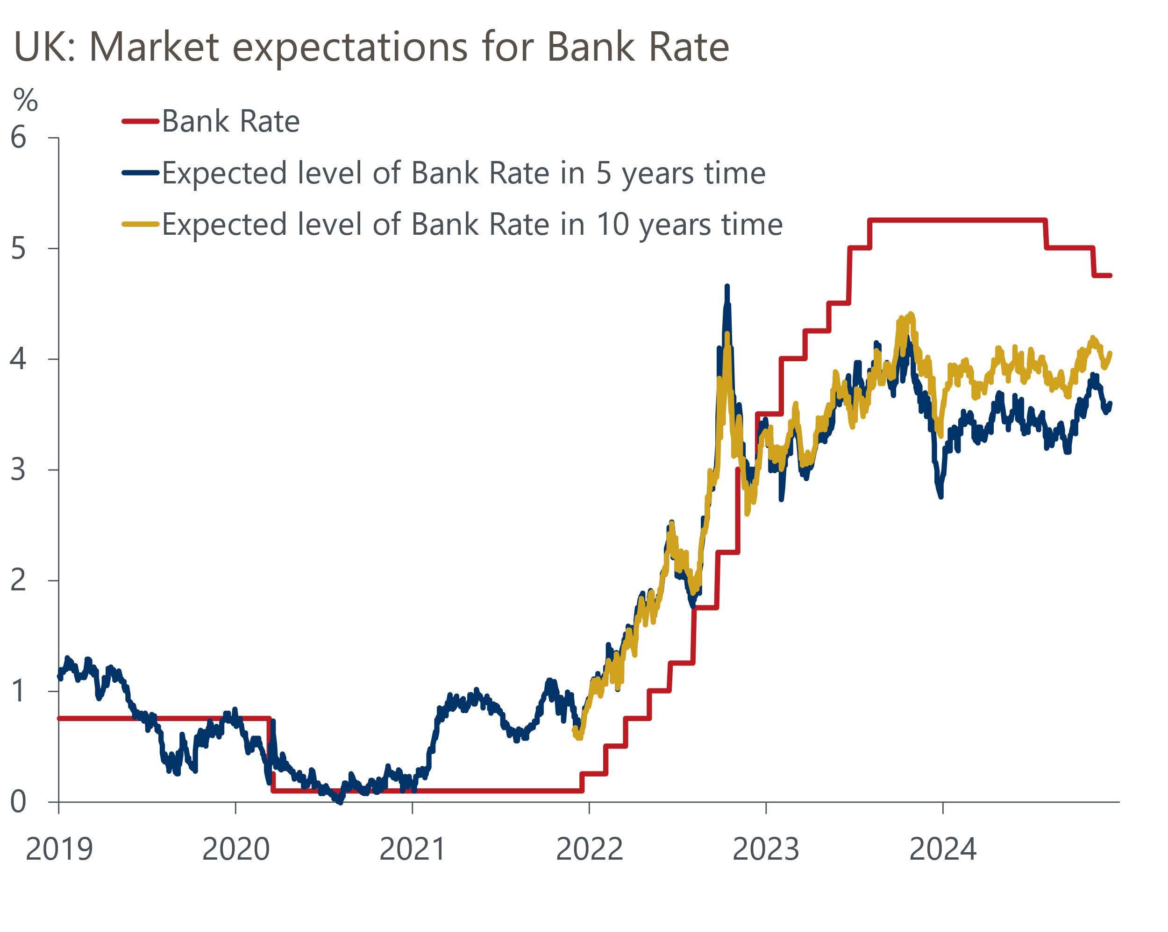
Source: Haver Analytics
Apart from being influenced by the current level of Bank Rate, we think markets are more concerned about the potential for inflation expectations to remain elevated. In terms of the real neutral rate, market participants appear not to put as much weight on arguments that demographics and weak productivity growth will exert a significant drag.

Path back to neutral likely to be gradual; term premium to stay elevated
The MPC has made clear that it expects to loosen policy gradually. So far, it has settled into a cut-hold tempo, and our baseline forecast assumes this continues through 2025. We think that high inflation – our forecast is for CPI inflation to average 3% next year, with core inflation still above 3% at the end of 2025 – will discourage the MPC from moving more quickly.
Further out, we expect the pace of cuts to slow, partly because this period will coincide with the peak impact of Trump's fiscal and trade policies on the global economy. Bank Rate will also be moving closer to where the MPC currently thinks the neutral rate might be (which is likely to be similar to the MAPS survey median). If we're right and the neutral rate is lower, it may take time for the MPC to adjust fully.
We also think the term premium will remain elevated. US policy changes mean high term premia are likely to be a feature across the world. But there's several domestic factors that suggest investors will remain wary about the UK specifically (Chart 4).
Chart 4: UK term premium is likely to remain elevated in the next few years
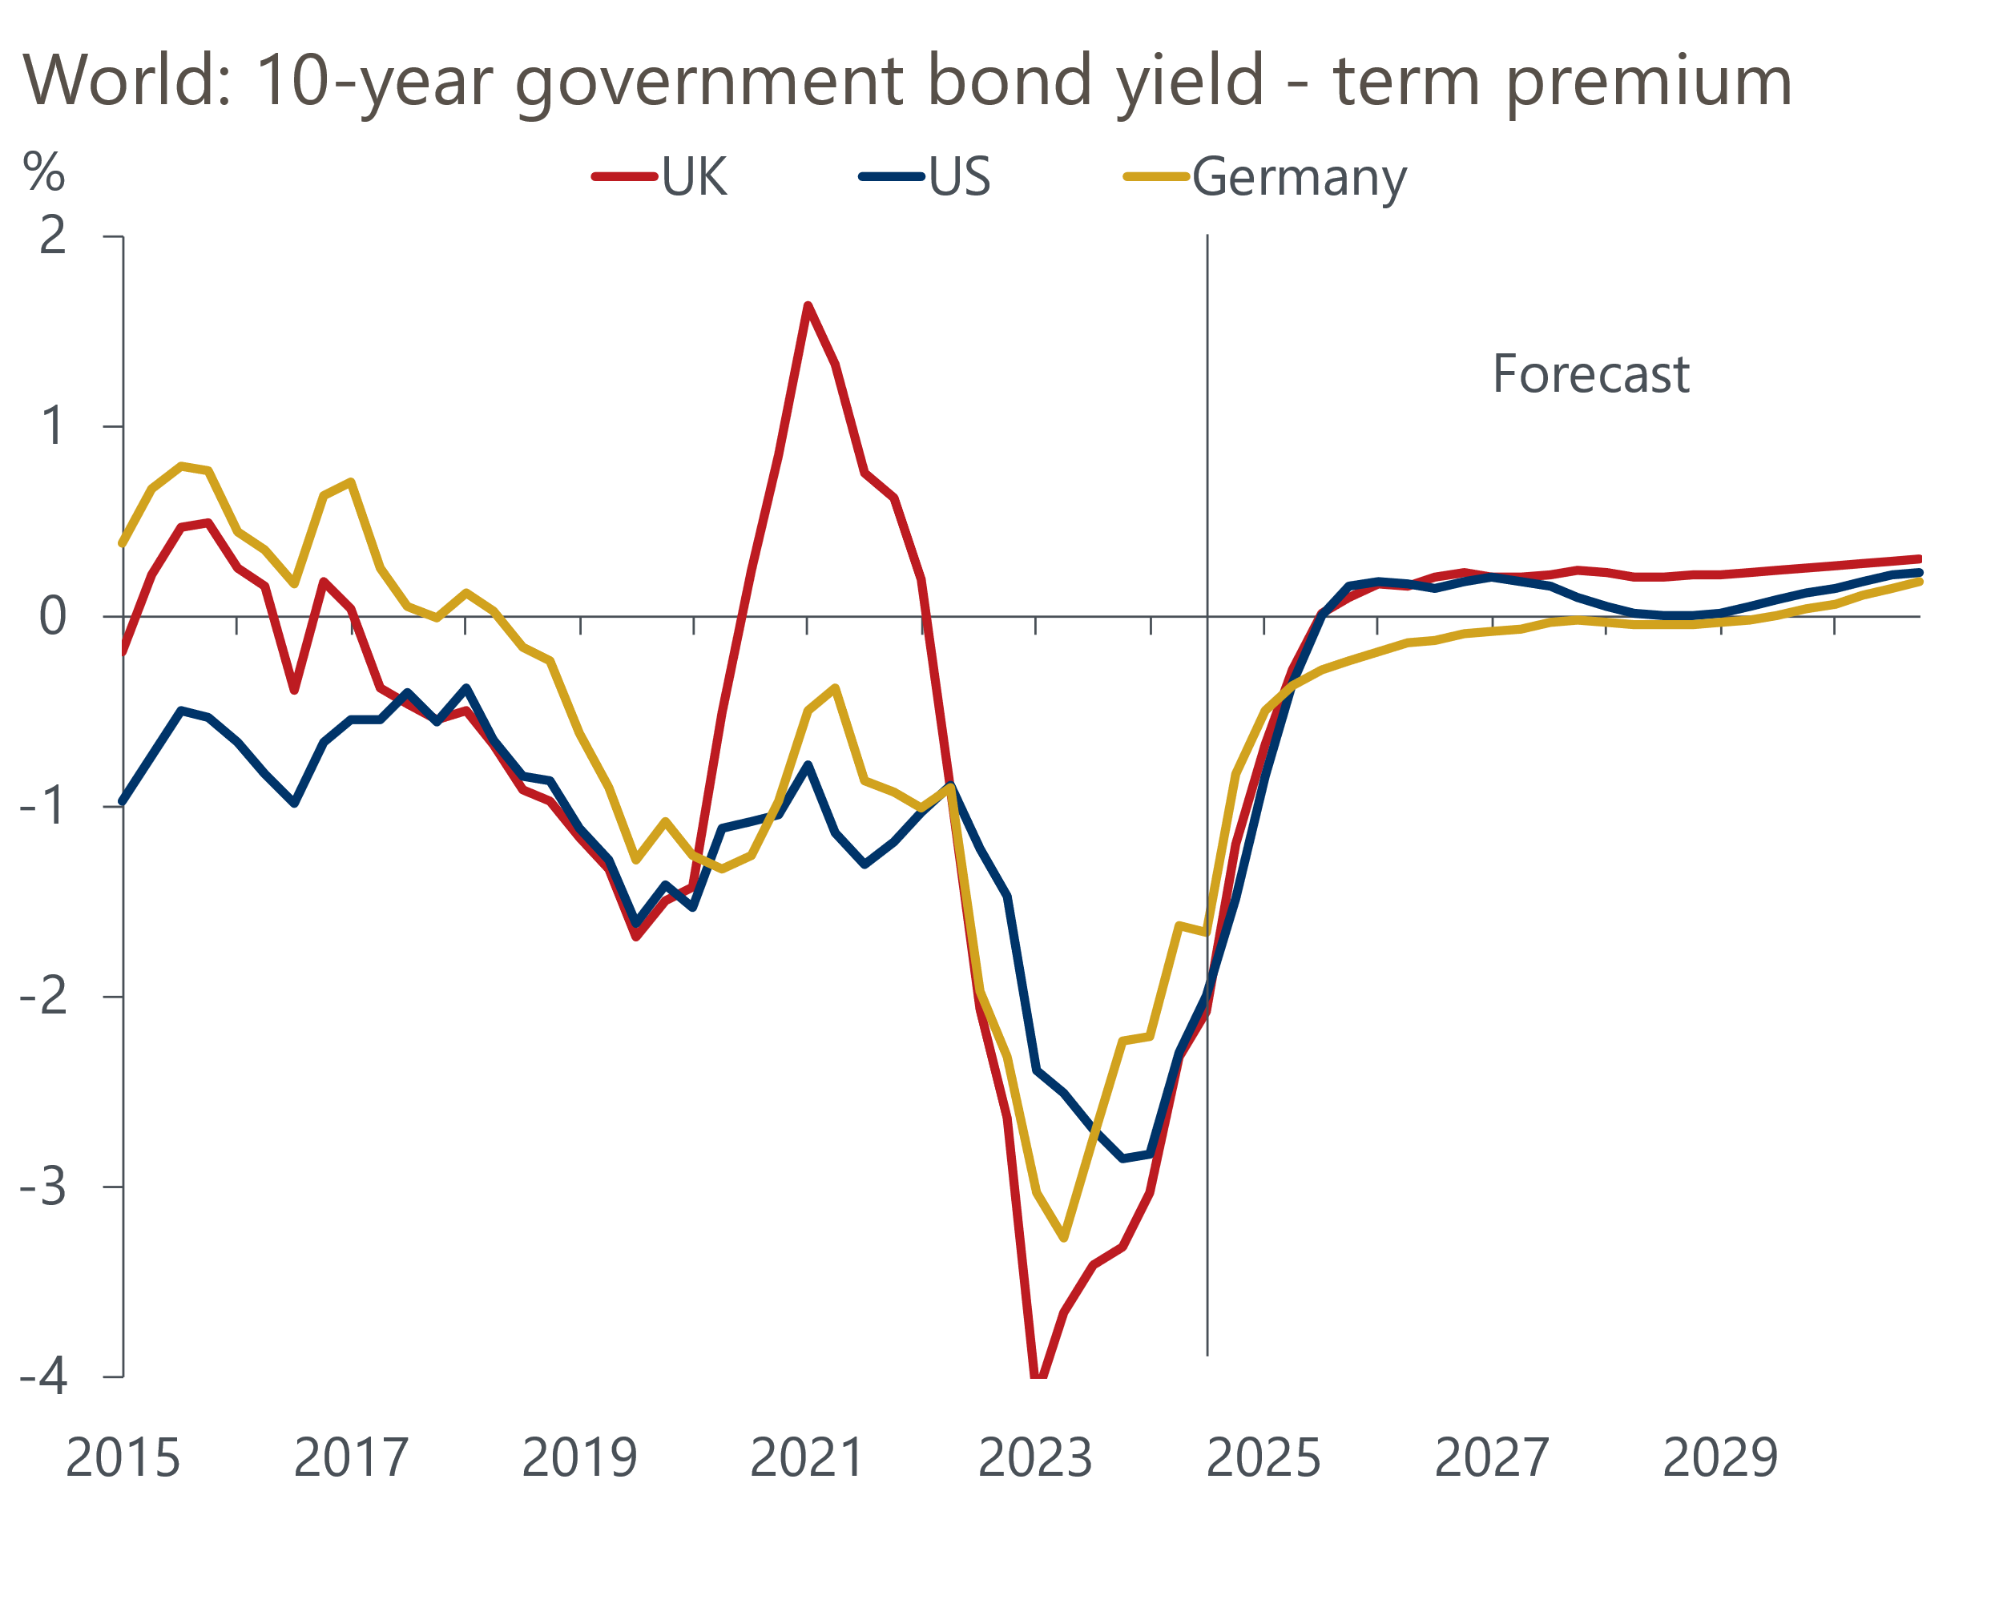
Sources: Oxford Economics, Haver Analytics
Concerns about fiscal sustainability are unlikely to go away. What's more, the government is yet to offer detailed policies that might convince markets that it can orchestrate a recovery from the dismal productivity performance that has now lasted almost two decades. The market also has to absorb a lot of extra gilt issuance as a result of the much higher borrowing plans announced in the Budget, with a lot of that extra supply coming at the medium- and long-end. This suggests that yields on longer-dated gilts are likely to remain particularly high over the next few years (Chart 5).
Chart 5: 20- and 30-year yields will remain particularly high in the near-term
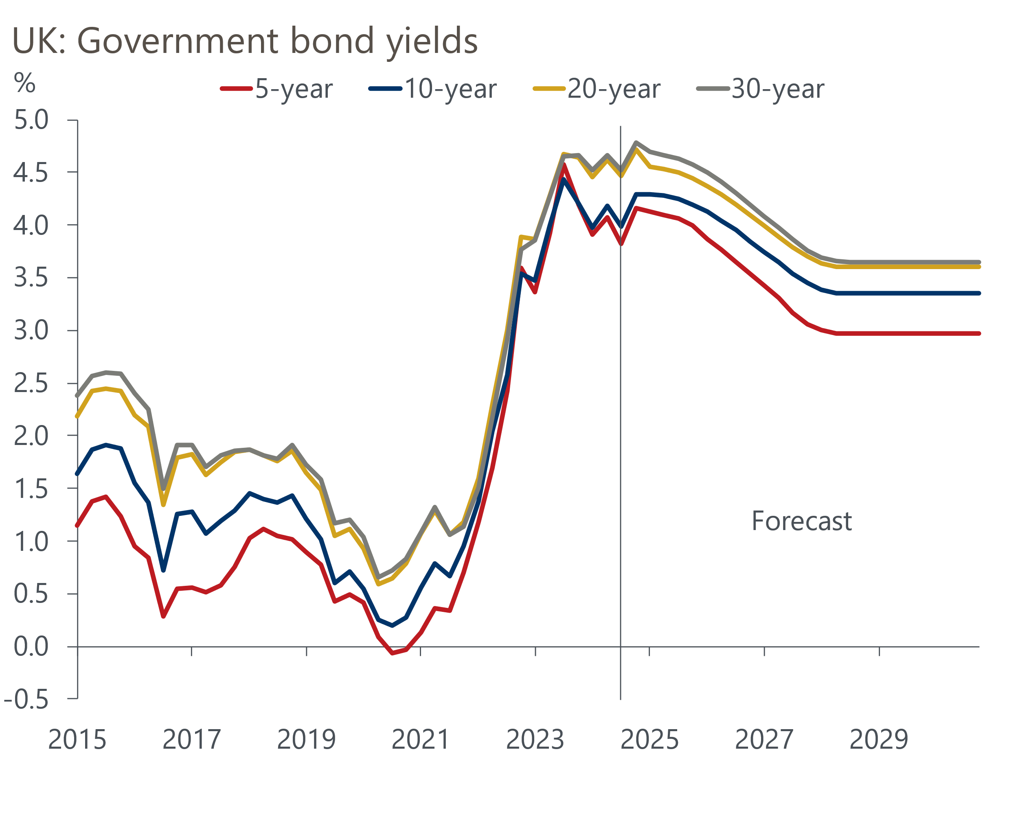
Sources: Oxford Economics, Haver Analytics

Outlook for the neutral interest rate under alternative macro regimes
The long-run neutral rate will be heavily influenced by how structural factors, such as globalisation demographics, and technological advancement, play out. Our Megatrends Scenarios Service, launching in early-2025, will quantify the macroeconomic impacts of key megatrends scenarios out to 2050. In the meantime, we have examined how the neutral rate might vary under different assumptions, arriving at the following scenarios ranked from the highest neutral rate to the lowest:
Technological Revolution. Technological advancements, such as AI, are successively deployed, supported by effective regulation and continued investment in R&D. A thawing in geopolitical tensions and retreat in protectionism results in greater knowledge sharing and drives stronger growth in labour productivity and innovation, boosting potential output growth. Stronger productivity growth would result in a much higher real neutral interest rate.
Fractured World. Geopolitical tensions continue to rise, resulting in persistent supply shocks and keeping commodity prices elevated. Trade decouples and FDI falls. New technological developments disappoint, while heighted uncertainty weighs on business investment. Initially this scenario would result in tighter monetary policy and a higher term premium than the baseline due to the increase in inflation. But over time, we would expect weaker productivity growth to pull the real neutral interest rate below the baseline.
Secular Stagnation. Productivity growth remains tepid as AI and other technological advancements disappoint and business investment growth is weak. The fertility rate falls faster than anticipated in the baseline, constraining the size of the working-age population and increasing the dependency ratio. Low productivity and nominal interest rates being constrained at the zero lower bound drag the real neutral interest rate below the baseline, while weak real earnings growth also keeps inflation expectations subdued.

